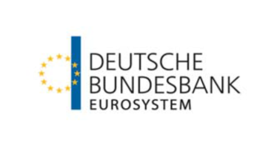

Monetary policy challenges

June 21–22, 2018
Banque de France, Paris, France

REGISTRATION FORM

Last name: First name:
Institution: Position:
E-mail:

I will attend the conference on Thursday morning ☐Yes ☐ No
I will attend the Thursday lunch conference ☐Yes ☐ No
I will attend the conference on Thursday afternoon ☐Yes ☐ No

I will attend the conference on Friday morning ☐Yes ☐ No
I will attend the Friday lunch conference ☐Yes ☐ No
I will attend the conference on Friday afternoon ☐Yes ☐ No

Please return this form by May 30th to: 1404-BDFBUBA-UT@banque-france.fr

